What is Flutter? (Big Picture)

1. Introduction
Flutter is an open-source UI software development kit (SDK) created by Google. It is used to build natively compiled applications for mobile (Android & iOS), web, and desktop from a single codebase.
In simple words:
Flutter allows developers to write one code and run it on multiple platforms with high performance and beautiful UI.

2. Types of Applications (Before Flutter)
Before learning Flutter, students should understand the different types of applications that exist today.
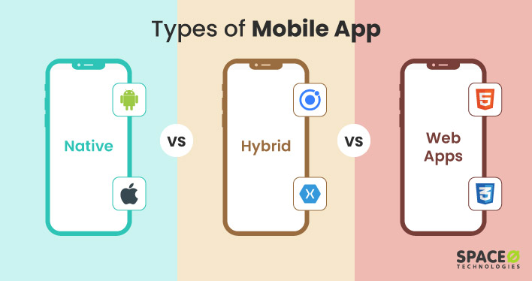

2.1 Native Apps
Native apps are built specifically for a single platform using its official language and tools.
- Android: Java / Kotlin
- iOS: Swift / Objective-C
Characteristics:
- Best performance
- Full access to device features
- Separate codebase for each platform
Examples: WhatsApp, Instagram (native core)

2.2 Web Apps
Web apps run inside a web browser and are built using:
- HTML
- CSS
- JavaScript
They do not need installation from an app store.
Characteristics:
- Runs in browser
- Easy to update
- Limited access to device hardware
Examples: Gmail, Google Docs

2.3 Hybrid Apps
Hybrid apps are web apps wrapped inside a native container.
They use:
- HTML
- CSS
- JavaScript
And run inside a WebView.
Characteristics:
- Single codebase
- Slower performance than native
- UI depends on browser rendering
Examples: Early versions of Ionic / Cordova apps

3. Why Flutter Was Created
Before Flutter, developers usually faced these problems:
- Separate codebases for Android and iOS
- High development and maintenance cost
- Inconsistent UI across platforms
- Slower UI performance in hybrid frameworks
Flutter was created to solve these issues by:
- Providing a single codebase
- Delivering near-native performance
- Allowing full control over UI design
- Enabling fast development with Hot Reload

3. What Makes Flutter Different

3.1 Single Codebase
With Flutter, you write your application once using Dart, and it works on:
- Android
- iOS
- Web
- Windows
- macOS
- Linux
This saves time, cost, and effort.
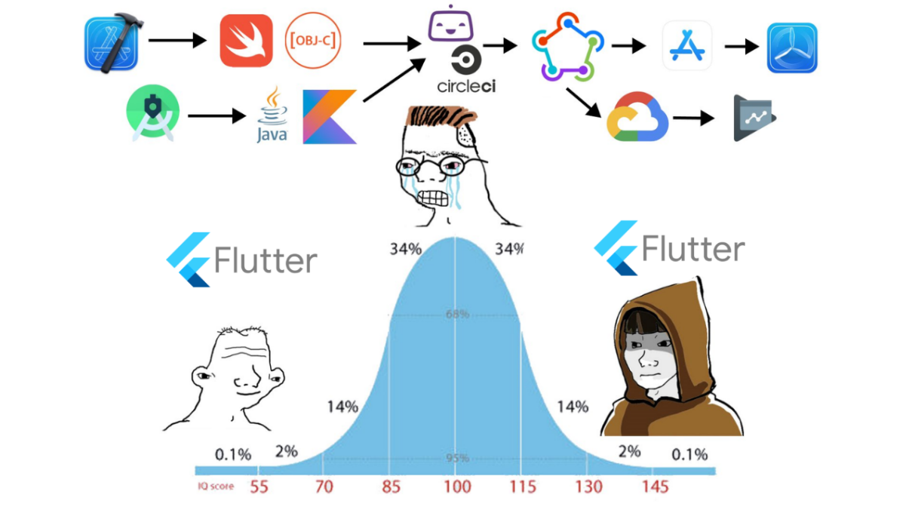

3.2 Everything is a Widget
In Flutter, everything is a widget:
- Text
- Button
- Image
- Padding
- Screen layout
Widgets are used to describe how the UI should look, not how to draw it.
This makes UI building:
- Consistent
- Reusable
- Easy to manage

3.3 Flutter Does NOT Use Native UI Components
Unlike other frameworks, Flutter:
- Does NOT use Android XML widgets
- Does NOT use iOS UIKit widgets
Instead, Flutter draws everything using its own rendering engine.
This results in:
- Same UI on all platforms
- No platform-specific UI bugs
- Better performance control

4. Dart Language (Flutter’s Backbone)
Flutter applications are written in Dart.
Why Dart?
- Fast execution
- Supports both JIT (development) and AOT (production)
- Optimized for UI development

Dart enables features like:
- Hot Reload
- Hot ReStart
- Smooth animations
- Predictable performance

5. Flutter Architecture (High-Level View)
Flutter is built using a layered architecture:
- Flutter Framework (Dart)
  - Widgets
  - State management
  - UI logic
  - Gestures
- Flutter Engine (C++)
  - Rendering (Skia)
  - Text layout
  - Image handling
  - Dart runtime
- Platform Embedder
  - Connects Flutter to Android, iOS, Web, Desktop
  - Handles lifecycle, input, and native APIs
This architecture makes Flutter fast and reliable.

6. Hot Reload (Developer Superpower)
Hot Reload allows developers to:
- See UI changes instantly
- Modify code without restarting the app
- Experiment with UI quickly
This drastically improves:
- Learning speed
- Development productivity

7. What Can You Build with Flutter
Using Flutter, you can build:
- Mobile apps (Android & iOS)
- Web applications
- Desktop applications
- MVPs and startups
- Production-level enterprise apps
Popular app categories:
- E-commerce
- Social media
- News & blogs
- Finance & fintech
- Education apps

8. Flutter vs Traditional Development
Feature | Flutter | Native Development
Codebase | Single | Separate
UI Consistency | Same everywhere | Platform dependent
Performance | Near-native | Native
Development Speed | Very fast | Slower
Hot Reload | Yes | No

9. Who Should Learn Flutter
Flutter is ideal for:
- Students learning app development
- Beginners entering mobile development
- Web developers moving to mobile
- Startups building fast MVPs
- Companies targeting multiple platforms

10. Summary (Big Picture)
- Flutter is a cross-platform UI framework
- Uses one codebase for many platforms
- Written in Dart
- Uses its own rendering engine
- Focuses on performance, UI consistency, and developer productivity
Flutter is not just a framework — it is a complete ecosystem for modern app development.

11. What to Learn Next
After understanding what Flutter is, the next topics should be:
- Dart basics
- Flutter project structure
- Widgets (Stateless vs Stateful)
- Layout system
- State management basics
This creates a strong foundation for Flutter development.

